

Hotel

Rustam Nasrulloev U1810294

Akhmedov Dilkhayot U1810158

Tokhir Kurbonov U1810199

Sardorjon Rakhimjonov U1810124

Eldorjon Obidov U1810222

Khusainov Khusniddin U1810179

Github repository: <https://github.com/iuthub/ip-group-project-friends-team>

Website link: http://hotres.eastus.cloudapp.azure.com

http://hotres.hopto.org

http://104.41.153.220

# Nowadays in Uzbekistan one of the well developing fields is tourism. That’s why we wanted make a website for booking hotel rooms and booking table in restaurant. Then we divided our website in small pieces like Home page, Booking Rooms, Bars & Restaurants & Blogs, Services, Gallery & About and Contact us pages.

# My name is Nasrulloev Rustam. My part was to make Bars & Restaurants & Blogs. And there are 4pages more for menu, blog, restaurant pages and for admins who enter with login can see admin table where users can occupy table without login and password this will be visible for admin table. There is restaurant page where everything partly contained from blog menu and booking and also blog page which is not finished. Blog page can be modified and add some more functions like adding post or modifying or deleting for admin. Furthermore, in menu pages also I could add more items.

# Now let me show you what it looks like

# 

# Here you can see as I said some sections and contents.

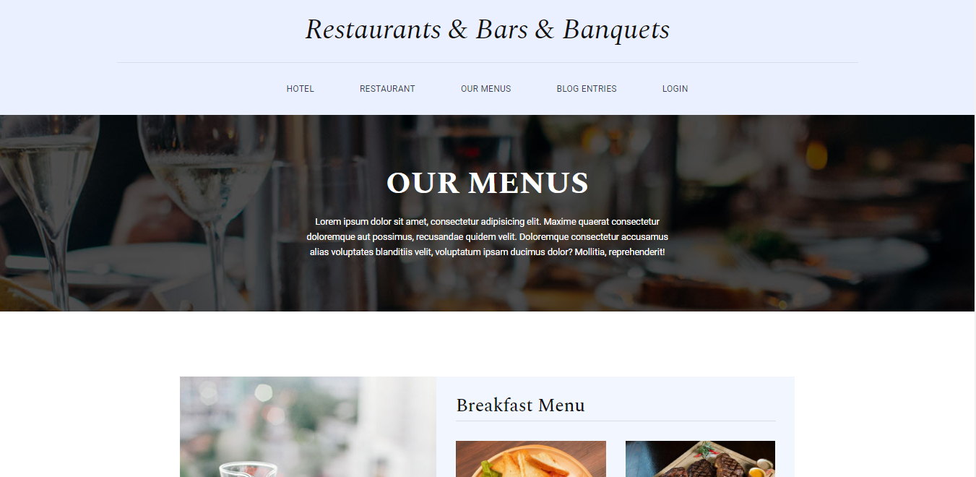

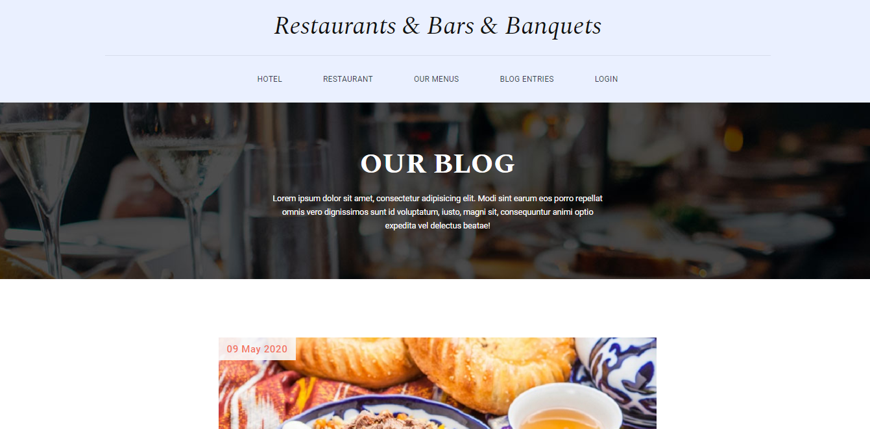

## As I said if you are login then you can see table

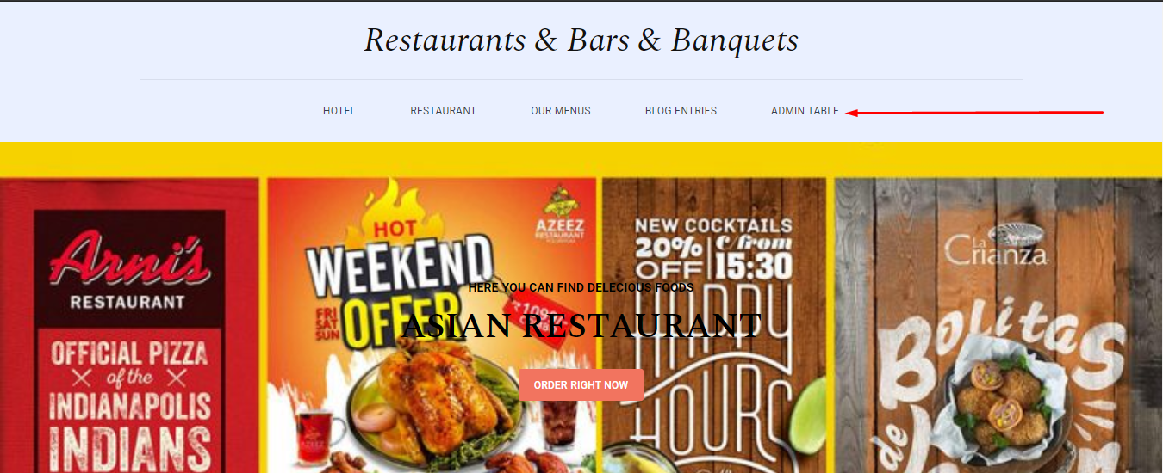

# Here is the content of the admin table page

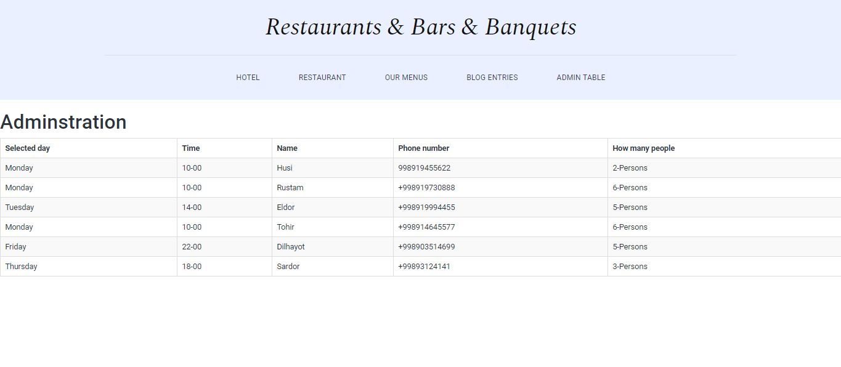

My name is Akhmedov Dilkhayot. My part was to make Landing page. Landing page is one of the important parts of our project. The reason why might be that any costumer pay more attention landing page. Landing page include three parts which are navigation, body and footer.

Navigation

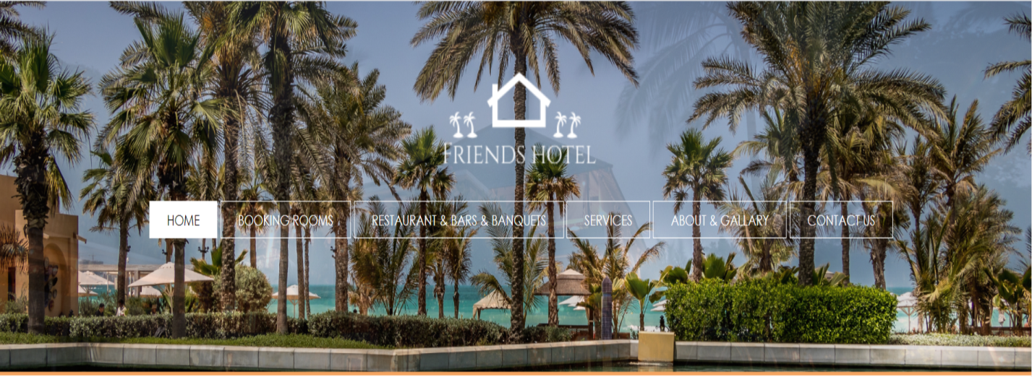

As you can see picture above is navigation part. Navigation part is also includes some parts which are other members jobs.

Body

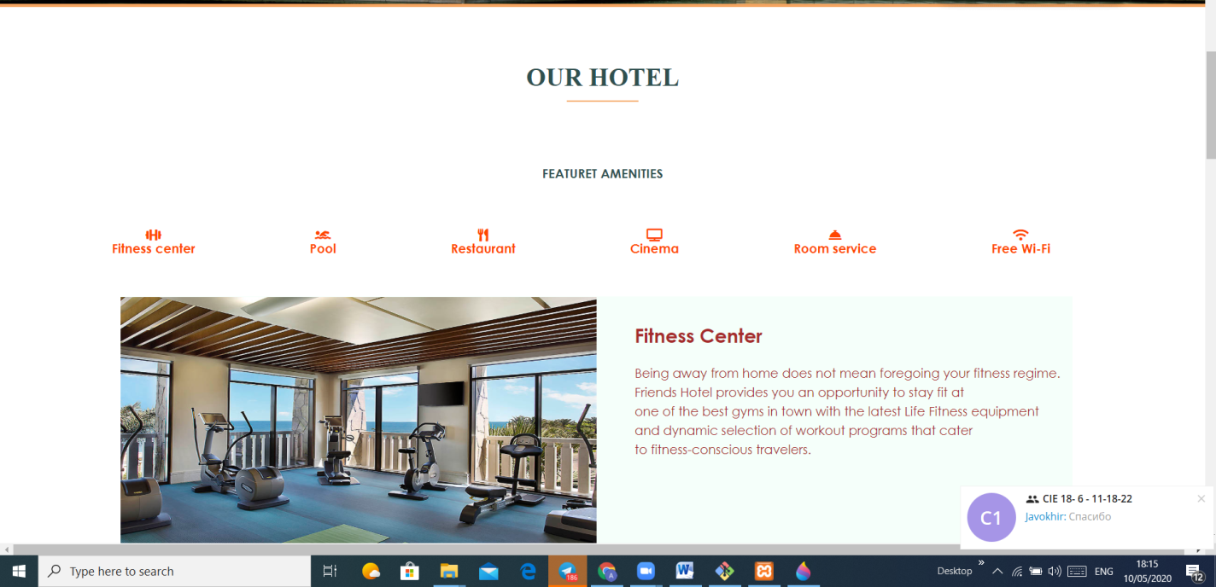

Body part is divided into two part first part is OUR HOTEL part. This part gives information about hotel’s featured amenities

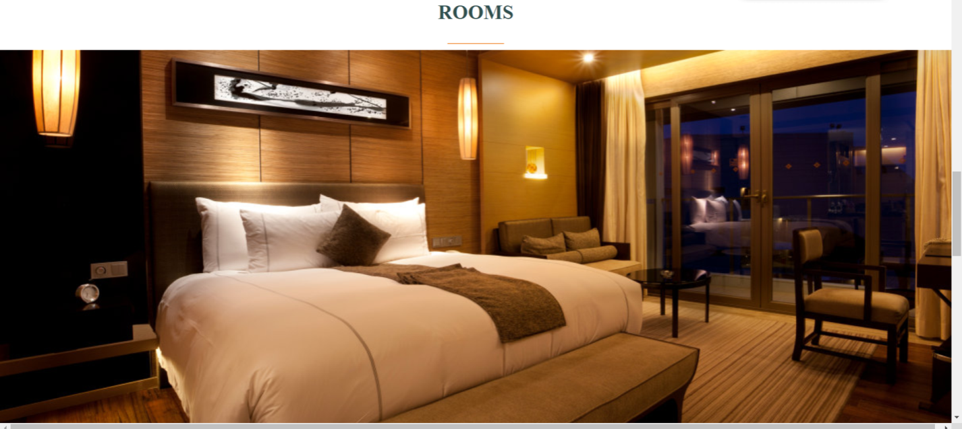

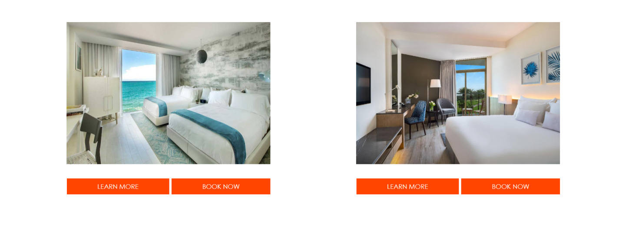

Second part is ROOM part. This part gives information about hotel’s rooms,

and costumers can book rooms.

Footer

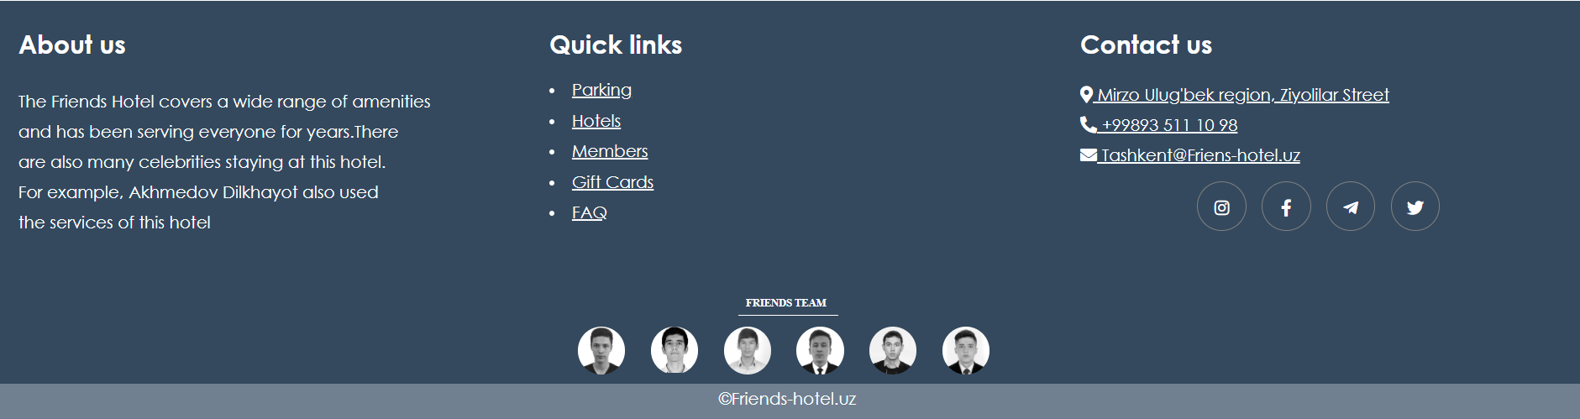

Users can choose quick links or read short information about hotel, team members. There are social media links for users. Users can watch life of hotel

***Contact Us Page***

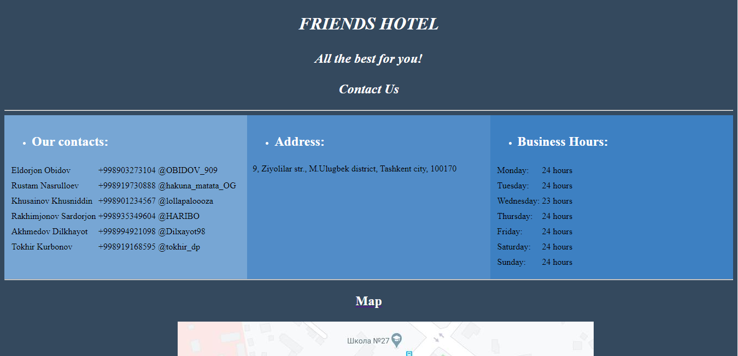

My name is Khurbanov Tokhir.

As you can see, there are information about us, like

* “Our contacts”, phone numbers and telegram nicknames of our team members for much comfort, one can call us or write;
* “Address”, as an address we gave IUT’s address for now…;
* “Business hours”, here you can see when the hotel is open, we gave as 24/7, because one may need a room at any time…

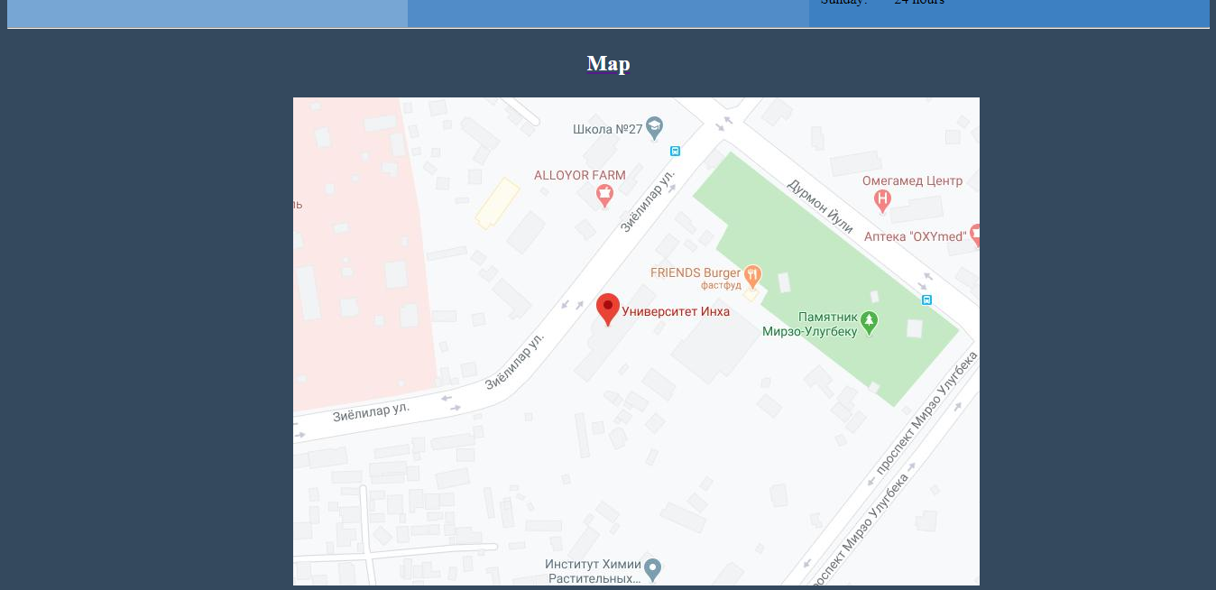

We also gave a google map to find direction easier and faster.

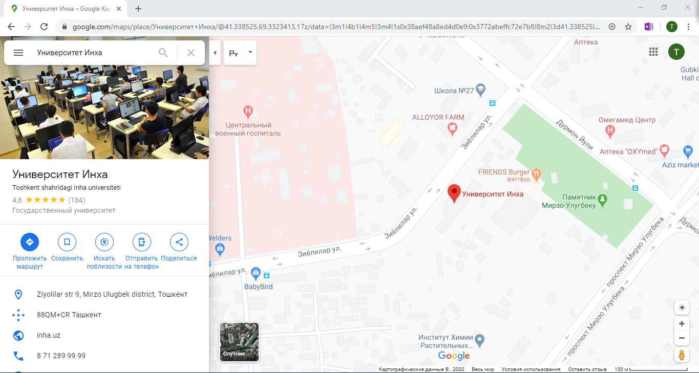

Here you can see the google map and some information about IUT.

Service page

My name is Sardorjon Rakhimjonov. My part in this project was to make Service page of our hotel. As you know, hotels are rated according to their facilities and services. The more diverse the services, the better. Hotels are designed not only to spend the night there, but also have a great time with people which are close to you. Our hotel will help you with this by providing you with its services at the highest level and will not make feel you indifferent.

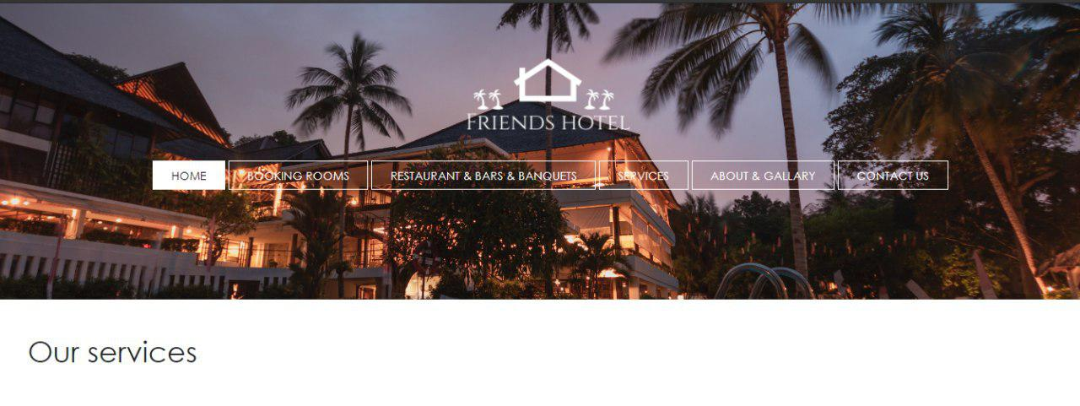

And here I want to introduce you the list of our services:

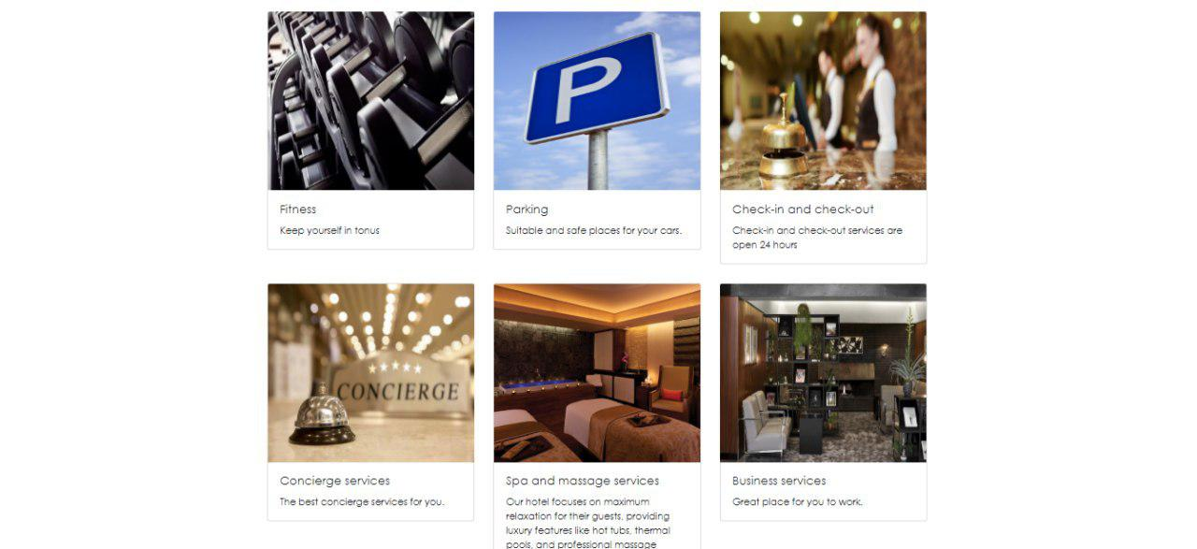

* **Fitness**

Fitness should be viewed no differently to any other lifestyle offering, whether it be hipster hangouts, authentic discovery, immersive community interaction or sustainability. The brands promoting these propositions target a carefully defined segment of travellers whom they know to be willing to pay more or to tolerate a tiny room or secondary location in order to consume a hospitality experience that aligns with their values.

* **Parking**

We have the pleasure to offer our guests parking at the specialized place for parking, which is located 100 meters from our Friends Hotel.

* **Check-in and Check-out**

We are welcome you to check-in or check-out at any time in case any rooms are available.

* **Concierge services**

Please enquire at reception and we will take care of it for you.

* **Spa and massage**

The spa and wellness center offers beauty treatments, massages and steam saunas.

* **Business services**

In the hotel's business lounge you will find a quiet environment with office space, relaxation area, national and international newspapers as well as computers and printers that can be freely used.

**Booking Page**

My name is Eldorjon Obidov, and in this project I participated in creating a page for booking hotel rooms. Booking is a new brand and convenient way to reserve a room number, a table in a restaurant, a ticket, or anything in advance. Booking is currently becoming a popular type of reserving, because there is no need to go, stand in line and wait, then come back again or to call and write an email, especially when you need to reserve something abroad from your country.

Firstly, I have started my work with brainstorming, think wath should be in booking page. At the beginning decided to create a table with class, room numbers, capacity, features, price and booking columns.

**Class:** There are three types of classes:

* Economy Class,
* Business Class
* First Class

**Room numbers**: In total, our hotel has 30 rooms.

**Capacity:** Each room has different number of beds from 1 bed up to 4 beds.

**Features:** Features depends on type of class. For example, room in Economy Class has No Features. Business Class Features: Free wi-fi, TV, Air condition, Telephone, 2-times lunch, Free pool access (some things will vary in quantity depending on capacity of room), First Class Features: Free fast wi-fi, 4K TV screens, Air condition, Telephone, daily newspaper, 3-times lunch, Free pool and gym access, Floor sensor lights, Inductive charging, Bluetooth furniture (some things will vary in quantity depending on capacity of room).

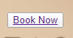**Price:** Economy Class: from 30$ up to 100$ per night (depending on capacity of room). Business Class Features: from 70$ up to 250$ per night (depending on capacity of room). First Class Features: from 100$ up to 450$ per night (depending on capacity of room).

**Booking**: made a clickable button to book a preferred room.

After all of the above things have been completed, I decided to make a table and put everything in it. Put the image in the background to make it look better.

**Economy Class Table:**

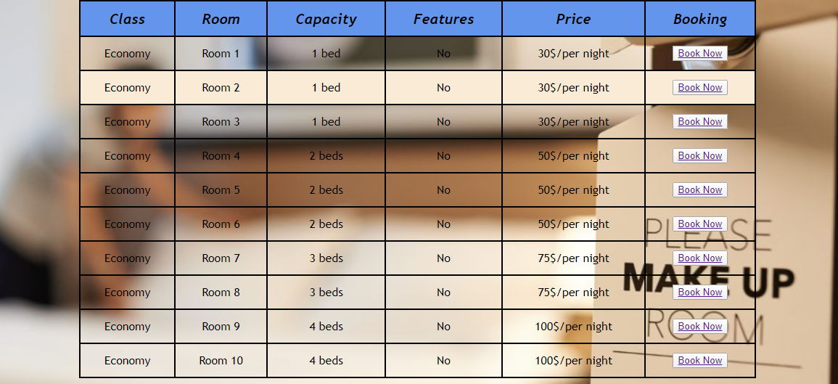

**Business Class Table:**

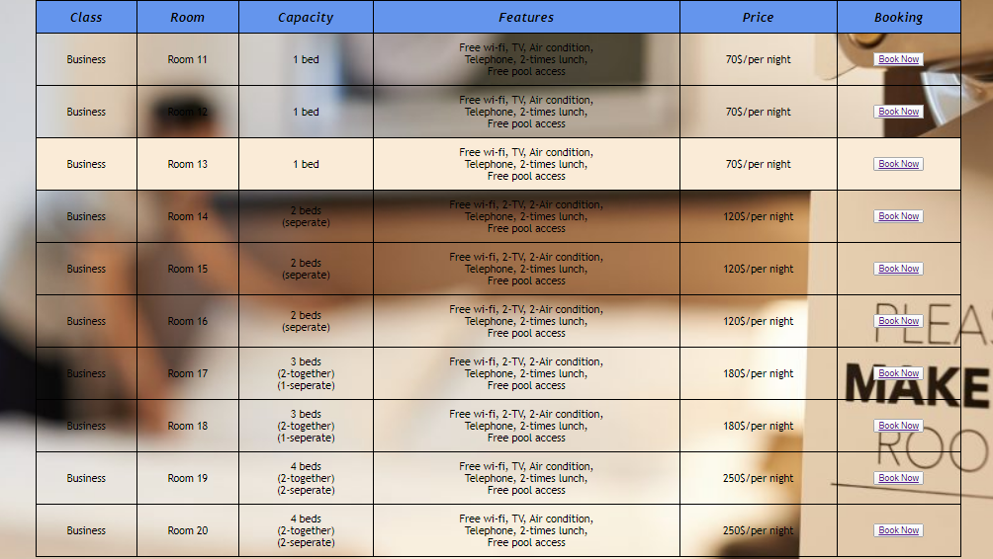

**Business Class Table:**



**First Class Table:**

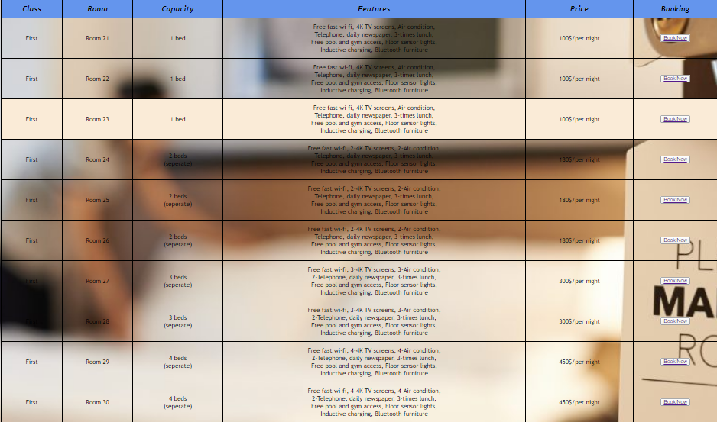

After completing table, I decided to split them to different pages. In this case I used pagination function.

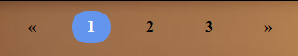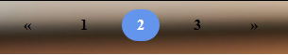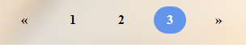**Pagination function:**

**Pagination** is the process of separating print or digital content into discrete pages.

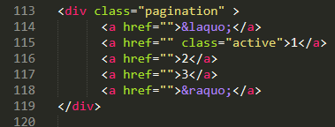&laquo – is an HTML entity that represents the symbol "<<"

&raquo – is an HTML entity that represents the symbol ">>"

class = “active” – is applied to the navigation element the user is currently viewing.

href = “#” – used to create a link to another page. used to create a link to another page.

When active class in turned, it will show the number of page where you are staying. Then if you want to go to another page it will give signal when you bring your mouse on it.

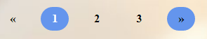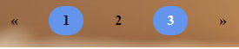

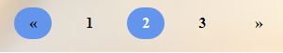

After completing table with pagination function, I decided to introduce you with our hotel rooms and put some images. In this case I used images from the internet.

**Economy Class Room Images:**

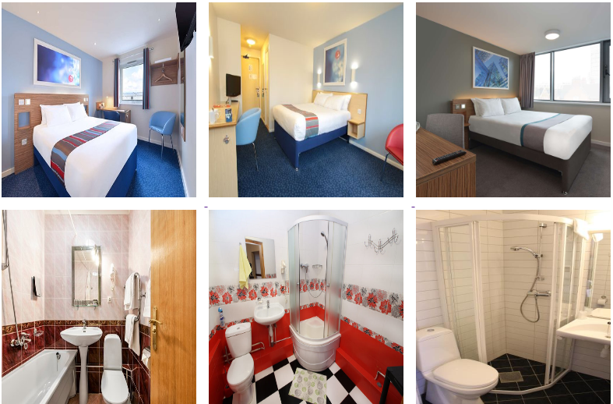

**Business Class Room Images:**

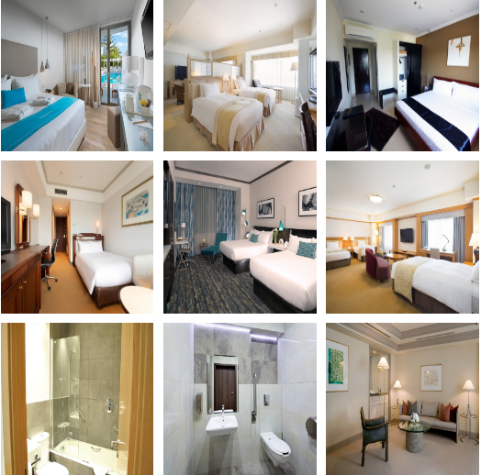

**First Class Room Images:**

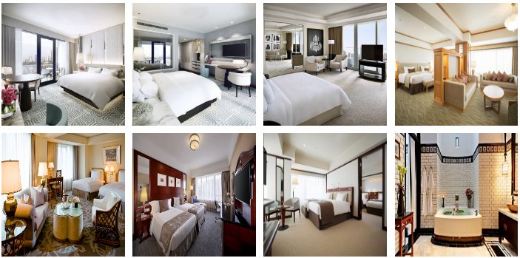

**About Page**

My name is Khusainov Khusniddin, and in this project I participated in creating a page to give some information about our hotel. As you know each site project should give information about itself. People tend to get more information about site. So my “about” page gives information where it is located, when our hotel was built and so on.

This is header of my page which was taken from landing page.

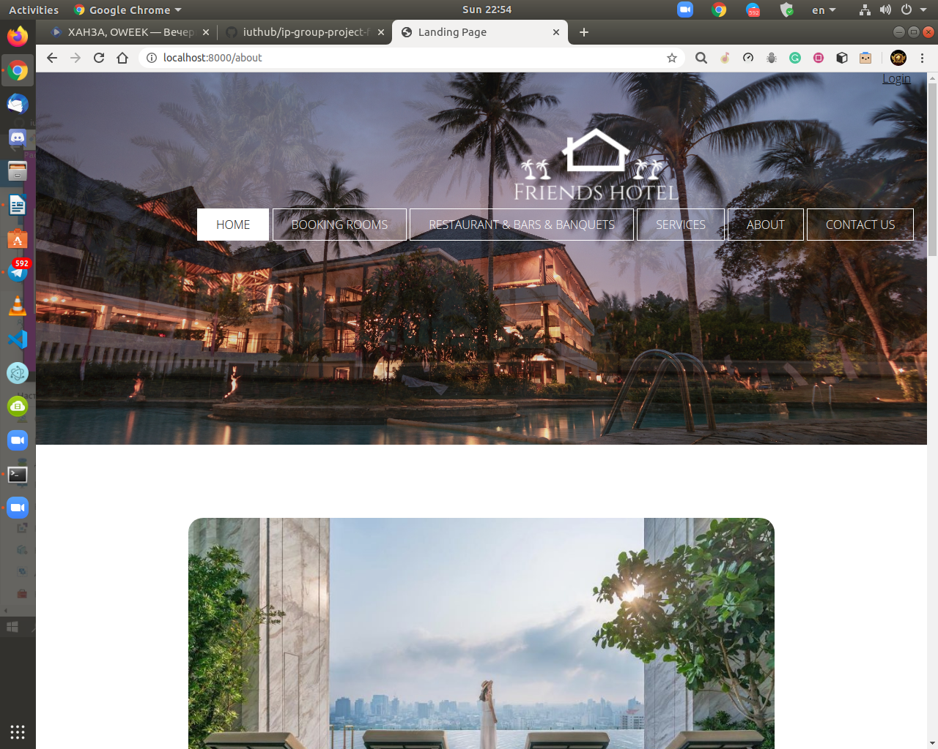

This is beginning of the content. I should mention that all information was taken from <https://www.jumeirah.com/en/jumeirah-group/about-jumeirah> this site.

And all this information doesnt match with reality.

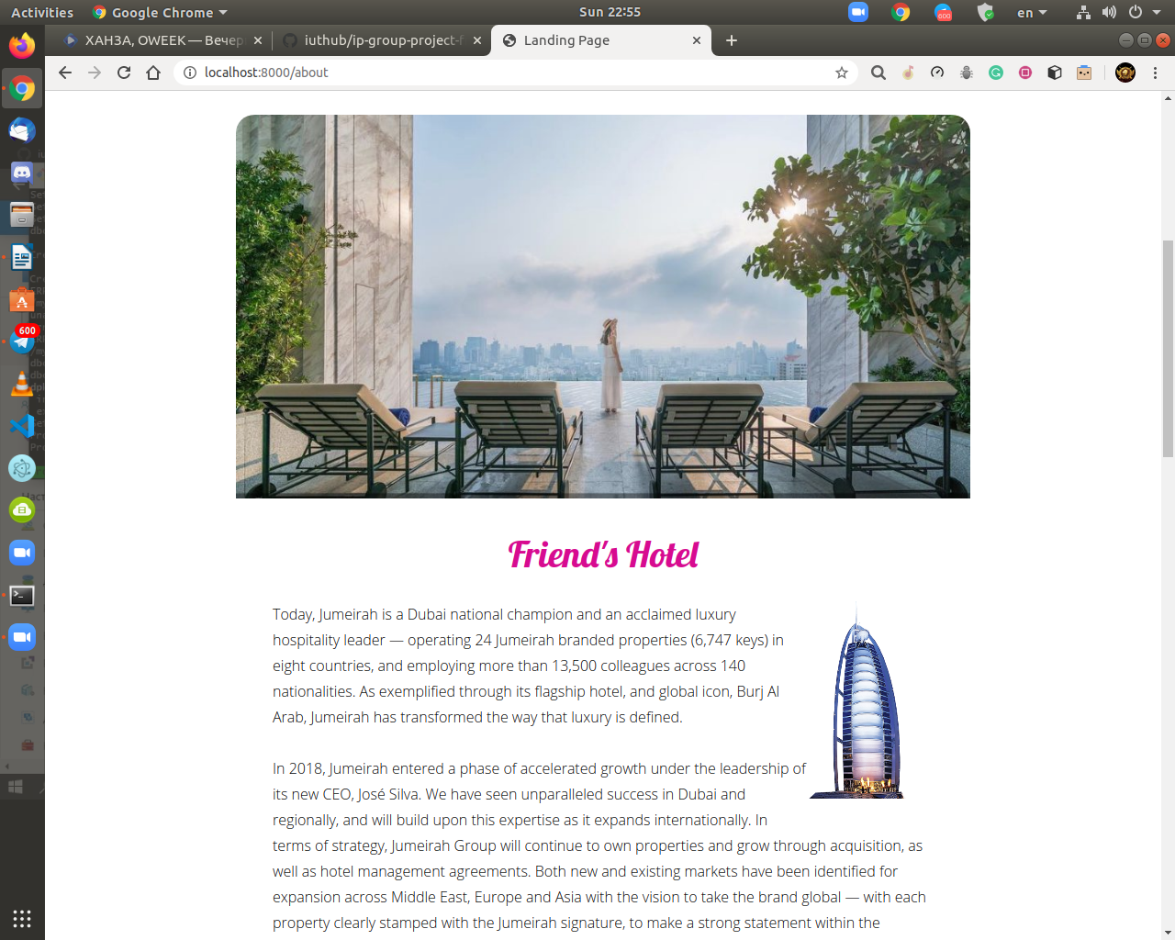

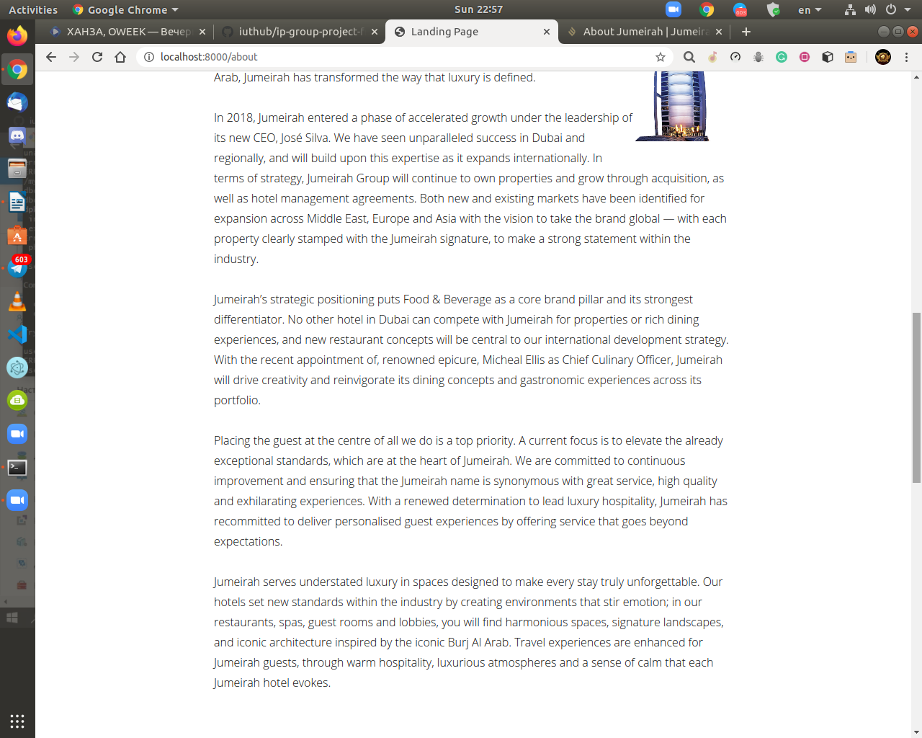

Then I added simple section which gives information to users that, We have a free party each Sunday. Everyone who wants can participate in this party by emailing beforehand to us. Also I gave information that where our hotel is located and when party starts.

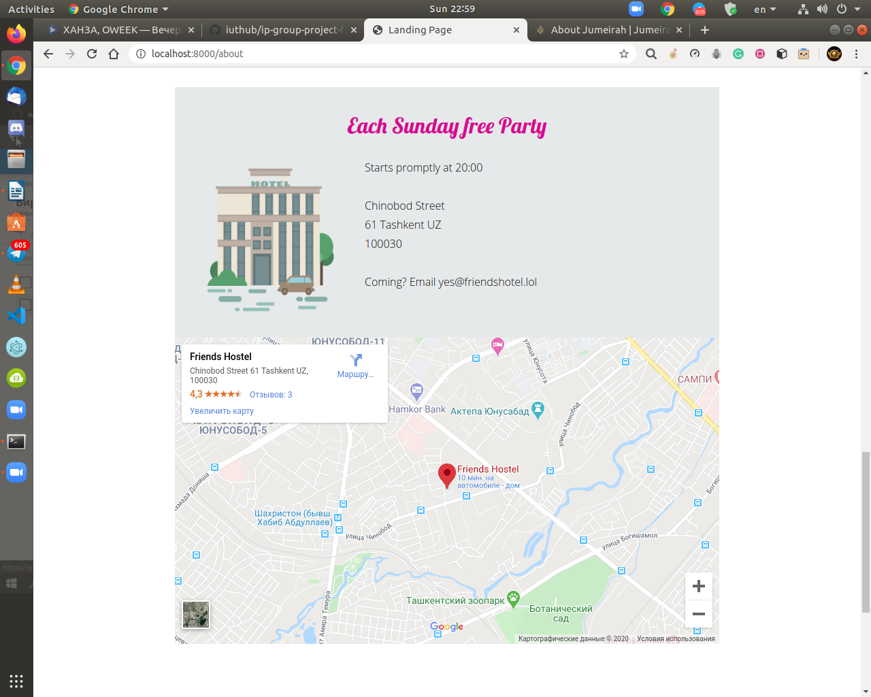

Moreover I added google maps, so it would be much more easier to find this place for users.

Finally I copied footer section from landing page

